First Request:
url : https://gateway-japa.americanexpress.com/api/rest/version/50/merchant/test8110291580/session

body: {"order": { "id": "dfdgsdf45435gfgf4571", "currency": "INR" }, "apiOperation": "CREATE_CHECKOUT_SESSION" }

response: {
"merchant": "test8110291580",
"result": "SUCCESS",
"session": {
"id": "SESSION0002443938760G6546097F96",
"updateStatus": "SUCCESS",
"version": "e91b7bbd01"
},
"successIndicator": "5394ab8ff6c44fd5"
}

Second Request:

url:

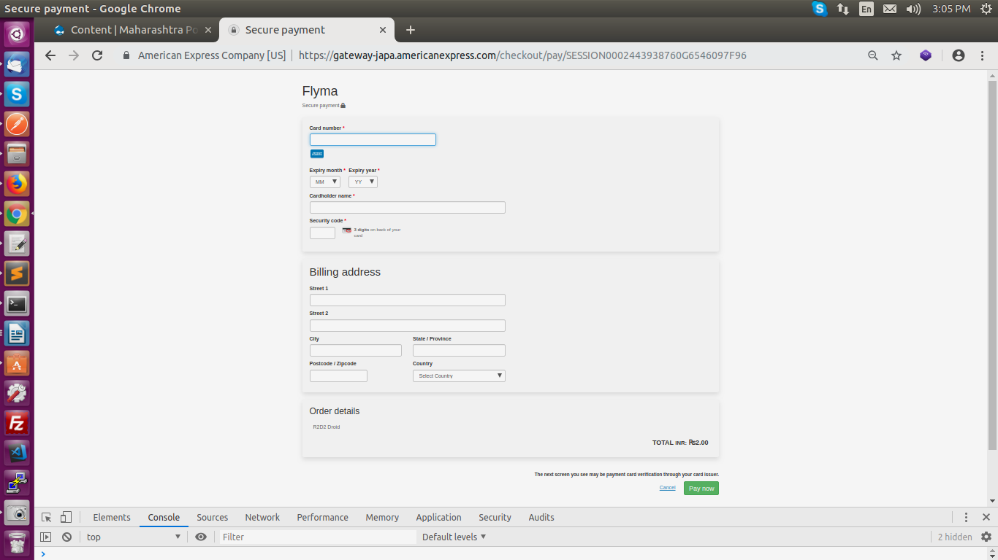

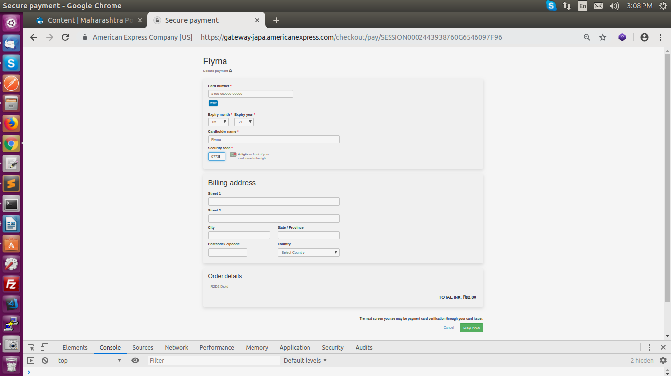
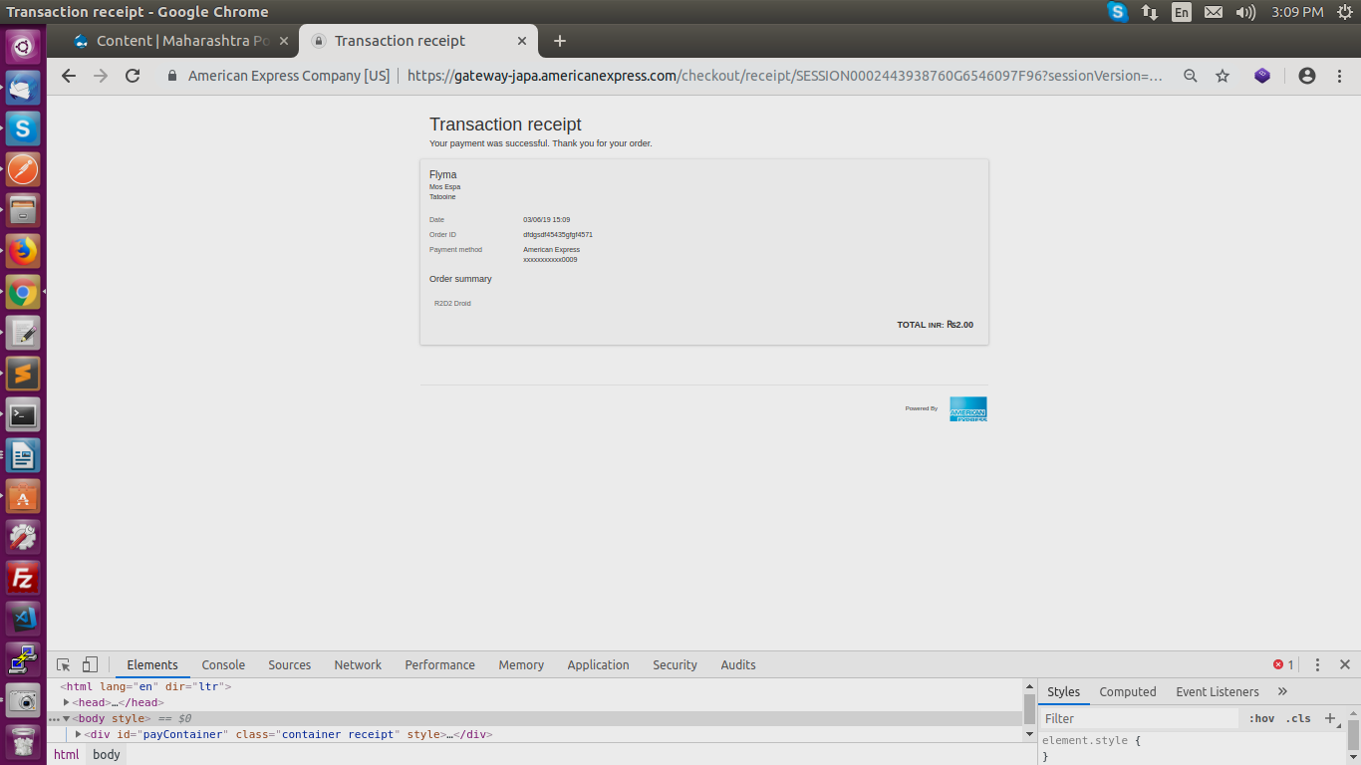

Need to provide this url in sccess callback function.
URL:

response:
{"amount":1.00,"billing":{"address":{"city":"csac","country":"IND","postcodeZip":"400042","stateProvince":"csacs","street":"csacda, cdsac"}},"chargeback":{"amount":0,"currency":"INR"},"creationTime":"2019-06-03T12:07:46.273Z","currency":"INR","customer":{"firstName":"Flyma"},"description":"R2D2 Droid","device":{"browser":"Mozilla/5.0 (X11; Linux x86_64) AppleWebKit/537.36 (KHTML, like Gecko) Chrome/73.0.3683.86 Safari/537.36","ipAddress":"206.183.111.25"},"id":"dfdgsdf45435gfgf4578","merchant":"TEST8110291580","merchantCategoryCode":"5962","result":"SUCCESS","risk":{"response":{"gatewayCode":"NOT_CHECKED","review":{"decision":"NOT_REQUIRED"}}},"sourceOfFunds":{"provided":{"card":{"brand":"AMEX","expiry":{"month":"5","year":"21"},"fundingMethod":"CREDIT","issuer":"AMERICAN EXPRESS","nameOnCard":"Flyma","number":"340000xxxxx0009","scheme":"AMEX","storedOnFile":"NOT_STORED"}},"type":"CARD"},"status":"AUTHORIZED","totalAuthorizedAmount":1.00,"totalCapturedAmount":0.00,"totalRefundedAmount":0.00,"transaction":[{"3DSecure":{"acsEci":"05","authenticationToken":"gIGCg4SFhoeIiYqLjI2Oj5CRkpM=","paResStatus":"Y","veResEnrolled":"Y","xid":"s950+dUOOaLLdSoB5rBnZXfXgcc="},"3DSecureId":"4b56fc4a-03b8-47b0-8aae-c87b80102b7b","authorizationResponse":{"posData":"1605S0100130","transactionIdentifier":"AmexTidTest"},"billing":{"address":{"city":"csac","country":"IND","postcodeZip":"400042","stateProvince":"csacs","street":"csacda, cdsac"}},"customer":{"firstName":"Flyma"},"device":{"browser":"Mozilla/5.0 (X11; Linux x86_64) AppleWebKit/537.36 (KHTML, like Gecko) Chrome/73.0.3683.86 Safari/537.36","ipAddress":"206.183.111.25"},"gatewayEntryPoint":"CHECKOUT","merchant":"TEST8110291580","order":{"amount":1.00,"chargeback":{"amount":0,"currency":"INR"},"creationTime":"2019-06-03T12:07:46.273Z","currency":"INR","description":"R2D2 Droid","id":"dfdgsdf45435gfgf4578","merchantCategoryCode":"5962","status":"AUTHORIZED","totalAuthorizedAmount":1.00,"totalCapturedAmount":0.00,"totalRefundedAmount":0.00},"response":{"acquirerCode":"000","acquirerMessage":"Approved ","cardSecurityCode":{"acquirerCode":"Y","gatewayCode":"MATCH"},"gatewayCode":"APPROVED"},"result":"SUCCESS","risk":{"response":{"gatewayCode":"NOT_CHECKED","review":{"decision":"NOT_REQUIRED"}}},"sourceOfFunds":{"provided":{"card":{"brand":"AMEX","expiry":{"month":"5","year":"21"},"fundingMethod":"CREDIT","issuer":"AMERICAN EXPRESS","nameOnCard":"Flyma","number":"340000xxxxx0009","scheme":"AMEX","storedOnFile":"NOT_STORED"}},"type":"CARD"},"timeOfRecord":"2019-06-03T12:07:46.273Z","transaction":{"acquirer":{"batch":214,"id":"AMEXGWS","merchantId":"8110291580"},"amount":1.00,"authorizationCode":"003493","currency":"INR","frequency":"SINGLE","id":"1","receipt":"190603459","source":"INTERNET","terminal":"VPOS5678","type":"AUTHORIZATION"},"version":"50"}]}

3rd Request:

URL:
https://gateway-japa.americanexpress.com/api/rest/version/50/merchant/test8110291580/order/dfdgsdf45435gfgf4583/transaction/gIGCg4SFhoeIiYqLjI2Oj5CRkpM=

Note: gIGCg4SFhoeIiYqLjI2Oj5CRkpM= is authentication token recived in response of second api.
Response:
{
"authorizationResponse": {
"posData": "1605S0100130",
"transactionIdentifier": "AmexTidTest"
},
"billing": {
"address": {
"city": "csacsa",
"country": "IND",
"postcodeZip": "400042",
"stateProvince": "ccascsa",
"street": "sas, csacs"
}
},
"customer": {
"firstName": "Flyma"
},
"device": {
"browser": "Mozilla/5.0 (X11; Linux x86_64) AppleWebKit/537.36 (KHTML, like Gecko) Chrome/73.0.3683.86 Safari/537.36",
"ipAddress": "206.183.111.25"
},
"gatewayEntryPoint": "WEB_SERVICES_API",
"merchant": "TEST8110291580",
"order": {
"amount": 1,
"chargeback": {
"amount": 0,
"currency": "INR"
},
"creationTime": "2019-06-04T04:04:38.177Z",
"currency": "INR",
"id": "dfdgsdf45435gfgf4583",
"merchantCategoryCode": "5962",
"status": "CAPTURED",
"totalAuthorizedAmount": 1,
"totalCapturedAmount": 1,
"totalRefundedAmount": 0
},
"response": {
"acquirerCode": "000",
"acquirerMessage": "Successful request",
"cardSecurityCode": {
"acquirerCode": "Y",
"gatewayCode": "MATCH"
},
"cardholderVerification": {
"avs": {
"acquirerCode": "S",
"gatewayCode": "SERVICE_NOT_SUPPORTED"
}
},
"gatewayCode": "APPROVED"
},
"result": "SUCCESS",
"risk": {
"response": {
"gatewayCode": "NOT_CHECKED",
"review": {
"decision": "NOT_REQUIRED"
}
}
},
"sourceOfFunds": {
"provided": {
"card": {
"brand": "AMEX",
"expiry": {
"month": "5",
"year": "21"
},
"fundingMethod": "CREDIT",
"issuer": "AMERICAN EXPRESS",
"nameOnCard": "Flyma",
"number": "340000xxxxx0009",
"scheme": "AMEX",
"storedOnFile": "NOT_STORED"
}
},
"type": "CARD"
},
"timeOfRecord": "2019-06-04T04:07:40.605Z",
"transaction": {
"acquirer": {
"batch": 215,
"id": "AMEXGWS",
"merchantId": "8110291580"
},
"amount": 1,
"authorizationCode": "003693",
"currency": "INR",
"frequency": "SINGLE",
"id": "gIGCg4SFhoeIiYqLjI2Oj5CRkpM=",
"receipt": "190604438",
"source": "INTERNET",
"terminal": "VPOS3456",
"type": "CAPTURE"
},
"version": "50"
}

